Orpha M. (Griffin) Roudebush-Adams
January 3, 1884 - 1953

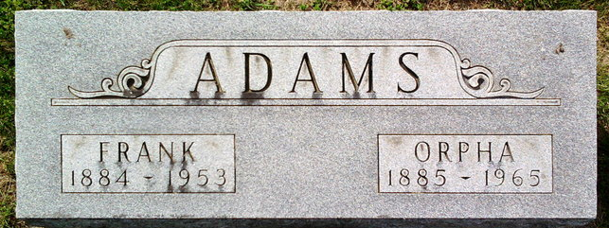
Photo by Thomas Liby
Indiana, U.S., Marriages, 1810-2001
Name Orpha May Rondebush
[Orpha May Griffin]
Gender Female
Race White
Age 43
Event Type Marriage Registration (Marriage)
Birth Date 10 Aug 1885
Birth Place Rockcreek Center
Marriage Date 27 Aug 1928
Marriage Place Indiana, United States
Residence Place Bluffton, Indiana
Father Wessley Griffin
Mother Sarah Falk
Spouse Frank Adams
Page 571
FHL Film Number 002318466
**
Indiana, U.S., Marriage Index, 1800-1941
Name Orpha M. Griffin
Marriage Date 4 Jul 1903
Marriage Place Wells, Indiana, USA
Spouse Name Thomas Roudebush

