Mary (Carlisle) Adams
October 7, 1870 – August 31, 1952

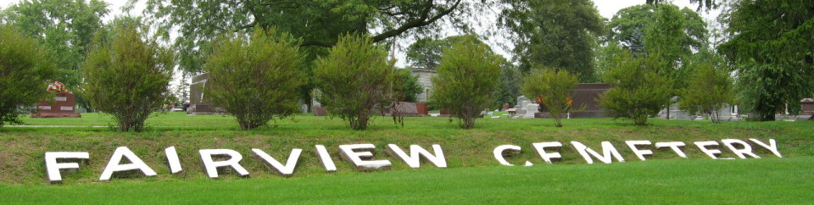
Photo by Tombstoner & Family

Indiana, U.S., Death Certificates, 1899-2017
Name Mary Carlisle Adams
[Mary Carlisle Carlisle]
Gender Female
Race White
Marital Status Widowed
Age 81
Birth Date 7 Oct 1870
Birth Place Ohio
Death Date 31 Aug 1952
Death Place Bluffton, Wells, Indiana, USA
Death Registration Date 1952
Father Patrick Heney Carlisle
Mother Anna Barbara Hower
Informant Mrs. Earl Fasling, Bluffton, IN
Burial 9-3-1952 Fairview

