John L. Adams
July 6, 1882 – September 15, 1934

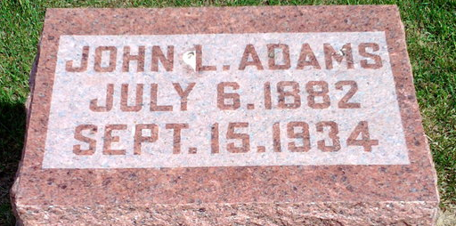
Photo by Thomas Liby
Indiana, U.S., Death Certificates, 1899-2017
Name John L. Adams
Gender Male
Race White
Marital Status Married
Age 52y, 2m 9d
Birth Date 6 Jul 1882
Birth Place Indiana
Death Date 15 Sep 1934
Death Place Bluffton, Wells, Indiana, USA
Death Registration Date 1934
Father Frank Adams, informant
Mother Louise Sowerwine
Spouse Pearl (Hardin) Adams
Burial 9-17-1934 Fairview
**
John L Adams from tree HARRIS-Newsome-Thornsberry-Hall-Thomas--2025-Good Tree

Birth 6 Jul 1882 Bluffton, Wells, Indiana, USA
Marriage 21 Mar 1912 Indiana, USA
Residence 1920 Bluffton, Wells, Indiana, USA
Death 15 Sep 1934 Bluffton, Wells, Indiana, USA
Father Frank M. Adams (1852-1908)
Mother Louisa Sourwine (1851-1901)
Spouse Chorlista Pearl Hardin White (Born 1886)
97976 People 14 Records 14 Sources

