Frank Adams
January 3, 1884 - 1953

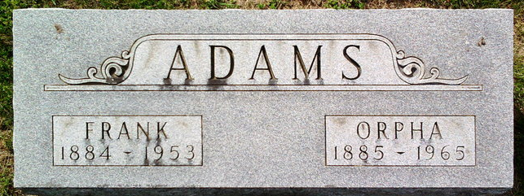
Photo by Thomas Liby

No further information found at this time.

