Frank Adams
June 25, 1852 – June 26, 1908

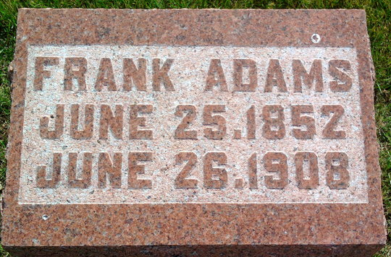
Photo by Thomas Liby

No further information found at this time.

