Elmer Alvin “Fred” Adams
September 20, 1870 – July 28, 1932

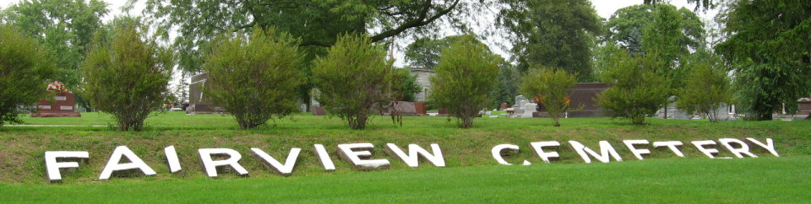
Photo by Tombstoner & Family
FRED ADAMS DIES OF HEART ATTACK
Fatally stricken while seeking medical aid at Doctor’s Home.

Elmer Alvin (Fred) Adams, 61, well known Bluffton ice dealer, a former deputy sheriff, died suddenly at 7 o’clock this morning from a heart attack which seized him as he went on to the front porch of the residence of Dr. C. H. Mead, 226 West Cherry street, in search of medical assistance.
He was accompanied to the physician’s home by Henry Inskeep, who drove there in Adams’ truck. When the physician answered their call Adams informed him that he had passed a very restless night and that his heart was bothering him. Hardly had he outlined his symptoms when he suffered the fatal attack and died almost instantly.
Mr. Adams had not been in good health since June 6, at which time he received a severe fall when a cake of ice he was carrying slipped out of the tongs. Since that time he had complained of internal disorder and in recent weeks his trouble had been diagnosed as heart involvement.
He was born in Hebron, Ind., Sept. 20, 1870, a son of Nelson and Anna Oliver Adams and was 61 years, 10 months and 8 days of age at the time of his death. On Jan 3, 1905, he was united in marriage to Marie Carlisle at Chicago.
They have resided in Bluffton the past twenty-two years. In recent years Mr. Adams delivered ice to customers in rural districts. He served as deputy sheriff during the four years his brother-in-law, Freem Carlisle, served as sheriff of Wells county. He was a member of the I.O.O.F. and L.O.O.M. lodes in this city.
Surviving besides the widow is one step-daughter, Mrs. Corrine Farling, wife of Earl Farling, Bluffton; two brothers, Emery Adams, Gary, and Eugene Adams, Hebron, and one sister, Mrs. Hannah Walton. Three sisters and one brother are deceased.
Funeral services will be conducted at 2 o’clock Saturday afternoon at the home, corner South and Jersey street, with Rev. H. N. Spear, pastor of the Baptist church, in charge. Burial will be in the mausoleum at Fairview cemetery.

Evening News Banner, Wells County, Indiana
Thursday, July 28, 1932, p. 1, col. 5

