Duane Loren Adams
May 20, 1965 – August 3, 2005

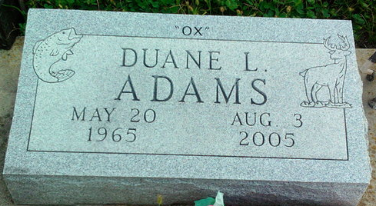
Photo by Thomas Liby
Duane Loren Adams, 40
A lifetime resident of Wells County, Duane Loren Adams, 40, of Bluffton, died at 8:20 p.m. Wednesday, Aug. 3, at his residence. Mr. Adams graduated from Bluffton High School. He worked for County Line Swine for the past six years and was also a landscaper for Turf Lawn/Landscaping Service in Bluffton for several years. He was a member of Moose Lodge #242 in Bluffton and Sonlight Wesleyan Church.
He was born May 20, 1965, in Bluffton to Eugene and Betty Baily Combs, who preceded him in death.
Survivors include his care giver and companion, Deborah Adams of Bluffton; two sons, Jeremiah and Ryan Adams of Portland; two step children, Ashley and Gavin Stanley of Bluffton; three sisters, Mrs. Tim (Karen) Vorndran of Fort Wayne, Mrs. Craig (Sharon) Young of Convoy, Ohio, and Mrs. Tony (Tina) Goodman of Muncie; and two brothers, Gayland and Phil Grogg of Bluffton.
Calling hours will be from 2 to 8 p.m. Friday at Thoma/Rich, Hewitt & Chaney Funeral Home. Services will be at 10:30 a.m. Saturday at the funeral home with Pastor Tom Bradley officiating. Burial will be at Fairview Cemetery in Bluffton.
Preferred memorials to the family through the funeral home.
Bluffton News Banner, Wells County, Indiana
Thursday, August 4, 2005

