Dixie Pearl Adams
August 9, 1917 – July 14, 1985

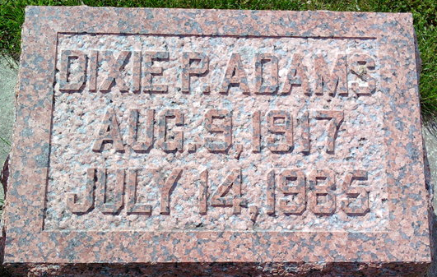
Photo by Thomas Liby

Indiana, U.S., Birth Certificates, 1907-1944

Name Dixie Pearl Adams
Gender Female
Birth Date 9 Aug 1917
Birth Place Bluffton, Wells, Indiana, USA
Father John L. Adams
Mother Pearl Hardin
Certificate Number 63992
Roll number 45385_539584
Volume Range 1232 – 1237
**

Ohio, U.S., Death Records, 1908-1932, 1938-2022

Name Dixie P Adams
Gender Female
Race White
Marital Status Not married (Married)
Death Age 67
Birth Date Abt 1918
Birth Place Indiana, USA
Residence Place Englewood, Montgomery, Ohio, USA
Death Date 14 Jul 1985
Death Place Dayton, Montgomery, Ohio, USA
Industry Eating and Drinking Places
Occupation Miscellaneous Food Preparation Occupations
Certificate Number 054429
Inquest Hospital Grandview Hospital
Inquest Questions Certifier: Physician; Autopsy Performed?: Yes, Used For Certification

