Chorlista P. (Harden) Adams
March 5, 1886 – December 3, 1953

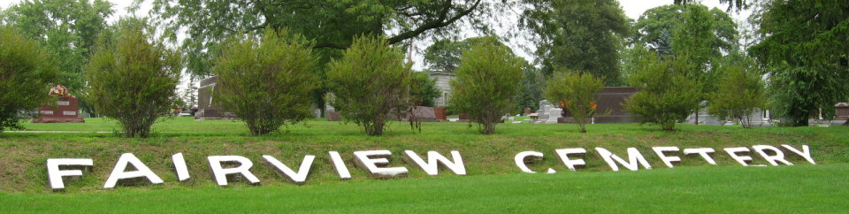
Photo by Tombstoner & Family

Chorlista Pearl Harden from tree All in the Family

Birth 5 Mar 1886 Decatur, Adams, Indiana, USA
Marriage 21 Mar 1912 Wells, Indiana, USA
Residence 1920 Bluffton, Wells, Indiana, USA
Death 1953 Bluffton, Wells, Indiana, USA
Father John Charles F "Mont" Harden (1862-1945)
Mother Sarah E "Sadie" Hackett (1869-1944)
Spouse John Vance White (1882-1926)
48511 People 12 Records 14 Sources
**

Cuyahoga County, Ohio, U.S., Marriage Records and Indexes, 1810-1973

Name Corlesta P Harding
Marriage Date 17 Jun 1906
Age 20
Gender Female
Birth Year abt 1886; Birth Place Indiana
Father Chas T Harding
Mother Sadie E Hackett
Spouse John V White
Spouse Age 24
Spouse Birth Year abt 1882
Spouse Father Samuel S White
Spouse Mother Rose Hickox
**

Indiana, U.S., Marriages, 1810-2001

Name Chorlista Pearl Hardin White
Gender Female
Race White
Age 26
Birth Date 5 Mar 1886; Birth Place Decatur, Adams, Indiana
Marriage Date 21 Mar 1912; Marriage Place Indiana, United States
Residence Place Bluffton, Indiana
Father John C F Hardin
Mother Sarah E Hardin
Spouse John L Adams
Page 233

