Billy K. Adams
April 5, 1938 – August 12, 2013

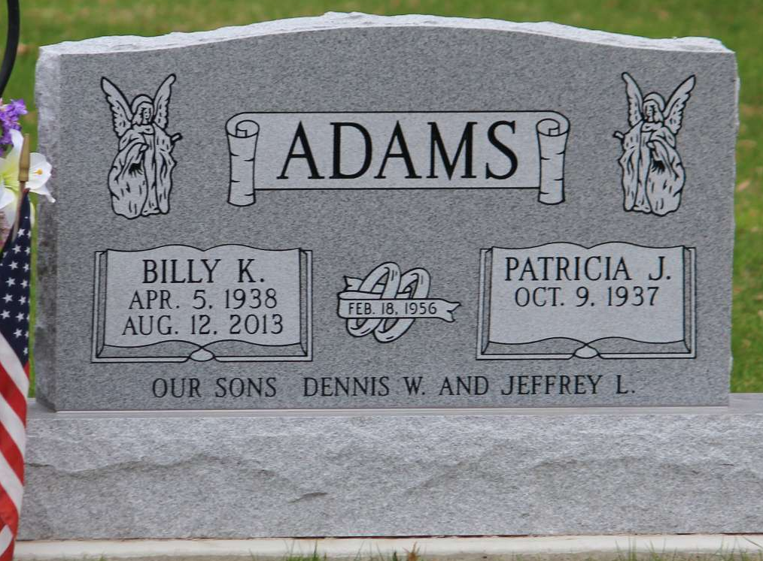
Photo by Tombstoner & Family
Billy K. Adams, 75, of Bluffton was surrounded by his family when he passed away on Monday, August 12, 2013 at Lutheran Hospital.
Billy was born in Wells County on April 5, 1938 to John and Ruby (Shannon) Adams. He married Patricia J. (Masterson) in Bluffton on February 18, 1956 and she survives.
Billy graduated from P.A. Allen High School and was a life-long resident of Wells County. He was a Truck Driver. His career included employment at Gladieux Refinery of Fort Wayne, Hulchers Emergency Service of Bluffton, and Franklin Electric Company.
Billy was an Indiana Army National Guard Veteran and a member of American Legion Post #111. He served as a Bluffton Fire Fighter for several years in the 1960's. He was a member of the Wells County Pilot's Association, the Bluffton Elks Lodge and the Bluffton Moose Lodge. He enjoyed golfing, singing, spending time with his family and he was an avid I.U. fan.
In addition to his wife, he is survived by two sons, Dennis Wayne Adams of Bluffton, Jeff Adams of Bluffton, four grandchildren, Erick Adams of Fort Wayne, Justin Adams of Bluffton, Chase Adams of Bluffton, Chelsea Adams of Bluffton, five great-grandchildren, two brothers, Howard Adams of Fort Myers, Florida, Robert Adams of Muncie, three sisters, Betty Johns of Bluffton, Mary Jo Satterfield of Bluffton, Elanda Sue Poff of Bluffton. In addition to his parents, he was preceded in death by a brother, Richard Adams, and by a sister, Ruth Ann Hollingsworth.
Calling hours will be 2:00 to 8:00 p.m. Thursday, August 15, 2013 and 10:00 a.m. to 11:00 a.m. Friday, August 16, 2013 all at Thoma/Rich, Chaney and Lemler Funeral Home. Elk's memorial services will be conducted by Bluffton Elks Lodge at 8:00 p.m. Thursday at the funeral home. Funeral services will be held at 11:00 a.m. Friday at the funeral home with Pastor Tim Miller officiating. Burial will be in Fairview Cemetery with military honors being conducted by American Legion Post #111.
Preferred memorials are to the Steve Kelly Cancer Relief Foundation.

Thoma/Rich Funeral Home, Wells County, Indiana
August 13, 2013

