Washington Acton
1850 - 1895

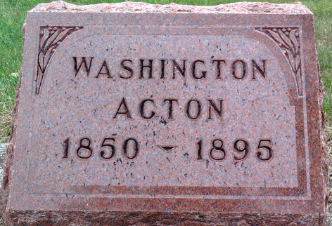
Photo by Thomas Liby

No further information found at this time

