Susan (Biglow) Acton-Nesbit
December 24, 1830 – December 15, 1910

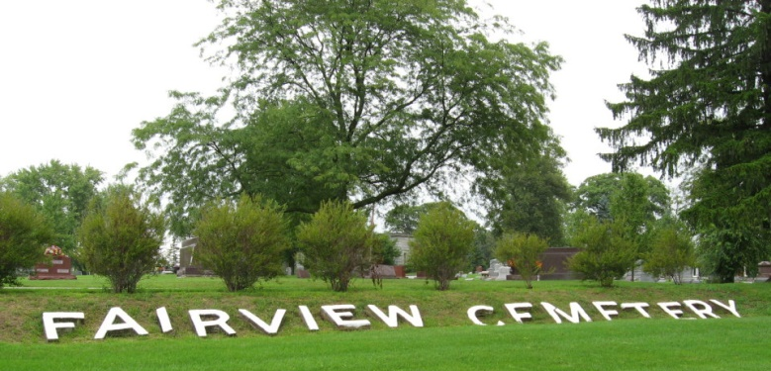
Photo by Tombstoner & Family
Susan Nesbitt
in the Indiana, U.S., Death Certificates, 1899-2011
Name: Susan Nesbitt
[Susan Biglow]
Gender: Female
Race: White
Age: 80 years, 11 months, 24 days
Marital status: Widow
Birth Date: 24 Dec
[abt 1830]
Birth Place: Franklin Co. Ohio
Death Date: 15 Dec 1910
Death Place: Bluffton, Wells, Indiana, USA
Father: Johnathan Biglow
Mother: Polly Curry
Spouse: John Acton & Abram Nesbitt
Informant: Rose Stout; Bluffton, Indiana
Burial: December 18, 1910; Fairview Cemetery

