Catherine (Sellers) Acton-Mumford
May 28, 1852 – April 11, 1928

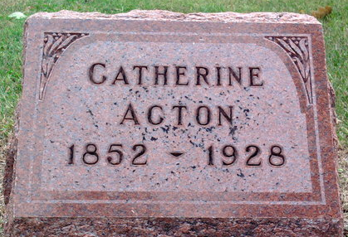
Photo by Thomas Liby

Mrs. Catherine Acton, 76, died Wednesday morning at the home of her son, William Acton, three miles west and one mile south of Roll.
Mrs. Acton was a daughter of Mr. and Mrs. K. B. Sellers of Wells County. Her husband, Washington Action is deceased.
She is survived by six children: Horton and Pearl Acton, Bluffton; Plinny Acton, William Acton, Mrs. Addie Cain and Mrs. Pauline Wasker, Detroit. A brother and a sister also survive.

Unknown source

**
Indiana, U.S., Death Certificates, 1899-2011
Name: Katherine Acton Mumford
[Katherine Sellers]
Gender: Female
Race: White
Age: 75
Marital status: Widow
Birth Date: 28 May 1852
Birth Place: Wells Co Ind
Death Date: 11 Apr 1928
Death Place: Monroe, Grant, Indiana, USA
Father: K. B. Sellers
Mother: ? Cline
Spouse: John Mumford; deceased
Informant: Horton Acton; Bluffton, Indiana
Burial: April 13, 1928; Fairview Cemetery

