Melvin Warren Acton
September 17, 1875 – July 3, 1924

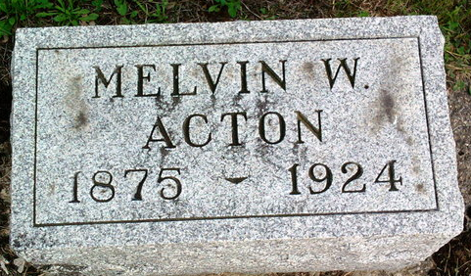
Photo by Thomas Liby

Melvin Warren Acton
in the Indiana, U.S., Death Certificates, 1899-2011
Name: Melvin Warren Acton
Gender: Male
Race: White
Age: 48
Marital status: Married
Birth Date: 17 Sep 1875
Birth Place: Bluffton, Ind
Death Date: 3 Jul 1924
Death Place: Bluffton, Wells, Indiana, USA
Father: Washington Acton
Mother: Catherine Sellers
Informant: Family; Bluffton, Indiana
Burial: July 6, 1924; Fairview Cemetery

