Lena Pearl Acton
April 15, 1890 – July 28, 1966

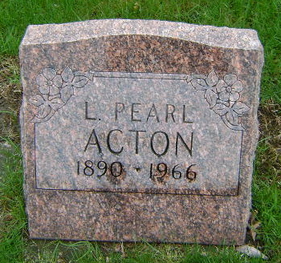
Photo by Bruce Sonner
Pearl Acton Was Ex-City Resident

Muncie, Indiana – Services for Pearl Acton, 76, a former Indianapolis resident will be at 1:30 pm tomorrow in the Thoma Funeral Home, Bluffton, with burial in Fairview Cemetery.
Miss Acton was found dead in her home in Muncie yesterday morning.
Blind since childhood, she was employed by the Indiana Association for the Blind in Indianapolis before moving to Muncie 10 years ago. She was a member of the Bluffton Methodist Church.
There are no survivors.

Unknown source

**
Indiana, U.S., Death Certificates, 1899-2011
Name: Pearl Lena Acton
Gender: Female
Race: Caucasian (White)
Age: 77
Marital status: Never Married (Single)
Birth Date: 15 Apr 1889 [sic]
Birth Place: Indiana
Death Date: 28 Jul 1966
Death Place: Muncie, Delaware, Indiana, USA
Father: Washington Acton
Mother: Katherine Sellers
Informant: Mrs. Dora Hill; sister-in-law; Ridgeville, Indiana
Burial: July 31, 1966; Fairview Cemetery; Bluffton, Indiana

