John Acton
1822 - 1880

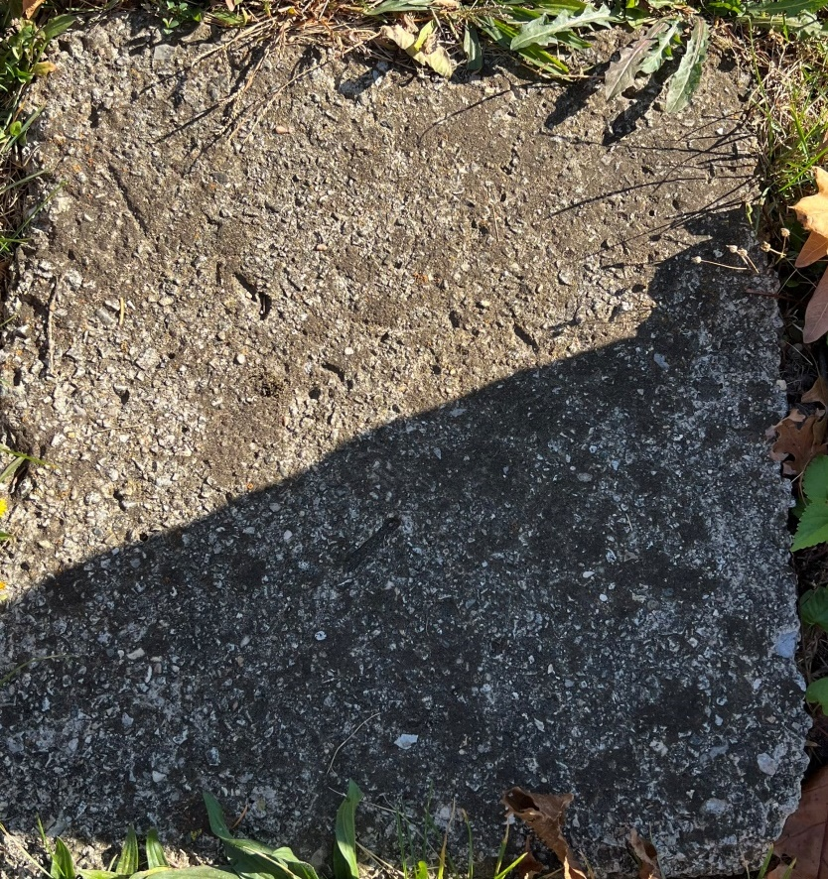
Photo by SMMR
No further information found at this time

