Clinton P. Acton
January 11, 1878 – October 2, 1964

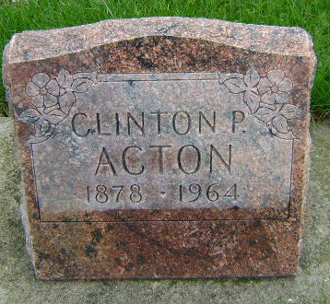
Photo by Bruce Sonner

Clinton Acton
in the Indiana, U.S., Death Certificates, 1899-2011
Name: Clinton Acton
Gender: Male
Race: White
Age: 35
Marital status: Never Married (Single)
Birth Date: 11 Jan 1879 [sic]
Birth Place: Wells Co
Death Date: 2 Oct 1964
Death Place: Bluffton, Wells, Indiana, USA
Father: Washington Acton
Mother: Catherin Sellers
Informant: Mrs. Lucille Cain; sister; Detroit, Michigan
Burial: October 5, 1964; Fairview Cemetery; Bluffton, Indiana

