Arrinda Jane (Trullender) Acton-Fulton
September 16, 1864 – August 31, 1947

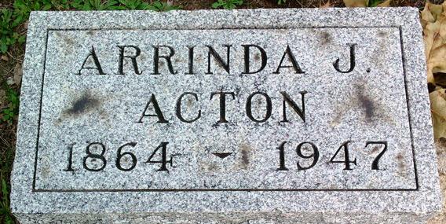
Photo by Thomas Liby
Arlinda Jane Fulton
in the Indiana, U.S., Death Certificates, 1899-2011
Name: Arrinda Jane Fulton
[Arlinda Jane Trullender]
Gender: Female
Race: White
Age: 83
Marital status: Widowed
Birth Date: 19 Sep 1863 [sic]
Birth Place: Wells County, Indiana
Death Date: 31 Aug 1947
Death Place: Bluffton, Wells, Indiana, USA
Father: Ruban Trullender
Mother: Mary Elizabeth Graham
Spouse: Frank Fulton
Informant: Curtis Fulton; son; city
Burial: September 1, 1947; Fairview Cemetery; Bluffton, Indiana

