Daniel Abenath
January 30, 1995 – March 27, 2011

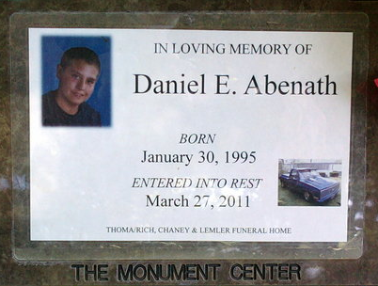
Photo by Thomas Liby
Daniel E. Abenath, 16, of Uniondale, died at 12:51 a.m. Sunday, March 27, 2011, at his residence. He was born in Wells County on Jan. 30, 1995 to Jack D. and Brenda (Bayes) Abenath Sr.
He was a sophomore at Norwell High School, and loved to work on cars and bikes. He attended the Poneto Baptist Church.
Other surviving relatives include two brothers, Brandon (Lindsley) Bayes of Fort Wayne and Jack D. (Heather) Abenath Jr. of Anderson; one sister, Candy Sue (Paul) Miller of Bluffton, and several aunts, uncles, nieces and nephews.
Calling hours will be from 2 to 8 p.m. Wednesday at the Thoma/Rich Funeral Home in Bluffton. Funeral services will be at 10 a.m. Thursday, at the funeral home with Pastor Alan Crull officiating.
Burial is at Fairview Cemetery, in Bluffton.
Preferred memorials are to the funeral home to pay for Daniel's funeral expenses.

Thoma/Rich Funeral Home, Wells County, Indiana
March 28, 2011

