Lana May (Steele) Abbott-Gordon
August 2, 1881 – January 30, 1962

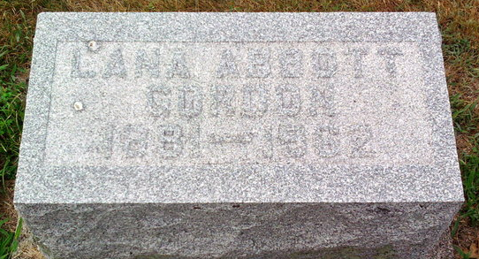
Photo by Thomas Liby
MRS. LANA GORDON DIES UNEXPECTEDLY
Mrs. Lana M. Gordon, 80, mother of Mrs. Truman Caylor of Bluffton, died unexpectedly late Tuesday afternoon at the Midway Airport in Chicago while en route here from California, where she had been visiting a daughter, Mrs. James Woodward of San Bernardino.
Born Aug. 2, 1881 in Adams County, she was the daughter of Samuel and Sarah Jane Krick Steele. A former resident of Bluffton and Fort Wayne, she had resided the past 11 years in Florida. She was a member of the Fort Wayne Chapter of the Order of the Eastern Star and was a member of the Church by the Sea in Miami Beach, Fla.
Surviving are two other daughters, Mrs. Ralph Stogdill of Fort Wayne and Mrs. Guy (Doris) Franceschani of Bryan, Tex.; one son, Harry Gordon of Hollywood, Fla.; a sister, Mrs. Harold Moore of Fort Wayne; two brothers, Morse Steele of El Jabean, Fla., and Arthur Steele of Fort Wayne; three grandchildren and one great-grandchild.
The body is at the Thoma Funeral Home, where friends may call after 7 p.m. Thursday. Services will be held at 1:30 p.m. Saturday at the funeral home with Rev. L. G. Sapp officiating. Burial will be in the Fairview Cemetery.

Bluffton News Banner, Wells County, Indiana
Wednesday, January 31, 1962

