Arthur Newton Abbott
January 13, 1875 – January 31, 1911

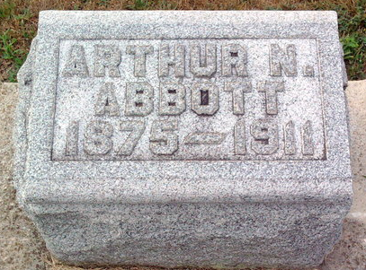
Photo by Thomas Liby
SUDDEN DEATH OF ARTHUR ABBOTT
Young Grocer Died Tuesday After Illness of Only One Day
Arthur Abbott, proprietor of the Abbott grocery on North Main Street, died at his home on Miller Street Tuesday at 1:30 p.m. after an illness of only a little more than twenty-four hours. He was taken ill about ten o'clock Monday morning while at work at his grocery and went home, apparently suffering from a severe attack of grip. He suffered from a high fever which went to 104, but Tuesday his temperature had returned to normal and the only affliction seemed to be severe rheumatic of neuralgic pains. The neuralgia centered in his stomach and in the afternoon affected his heart, causing his death after a very short interval.
Mr. Abbott was the son of Rev. and Mrs. D. W. Abbott, of Craigville and was born in Mercer County, Ohio, some thirty-six years ago. He came to this county with his parents and after he grew old enough to leave home he went to Fort Wayne where he was employed as an insurance agent. Later he worked at Ossian. He was married about ten years ago to Miss Lena Steele, of Peterson.
Mr. and Mrs. Abbott came to this city some four years ago. He was employed for several years as a clerk in the G. E. Stover Grocery on North Main Street and later bought his own grocery from John Weinland about two years ago. He was one of the most cheerful and agreeable of men and his business career was marked by absolute integrity. He has a host of friends in the city and county who will be most painfully shocked to learn of his untimely demise.
Surviving him are his parents, Rev. and Mrs. D. W. Abbott, of Craigville; his wife, Mrs. Lena Abbott; three children, Eva, 9; Louis [sic], 7; and Florence, 5; and the following brothers and sisters: Alfred, of Craigville, Merritt, of this city; Elmer, Lancaster township; Nelson, near Craigville; Mrs. Rosa Hetrick, Craigville and Edgar, of Craigville, who assisted his brother in his grocery until last fall. One sister, Mrs. Emma Warthman died a short time ago and another brother died in infancy.
Mr. Abbott's parents were summoned from Craigville this afternoon but did not arrive until after he had breathed his last. His own family and three brothers, Alfred, Merritt and Edgar were at his bedside at the end.

Bluffton Chronicle, Wells County, Indiana
Wednesday, February 1, 1911

