Evelyn M. (Hartman) Williams
September 15, 1942 - April 25, 2014

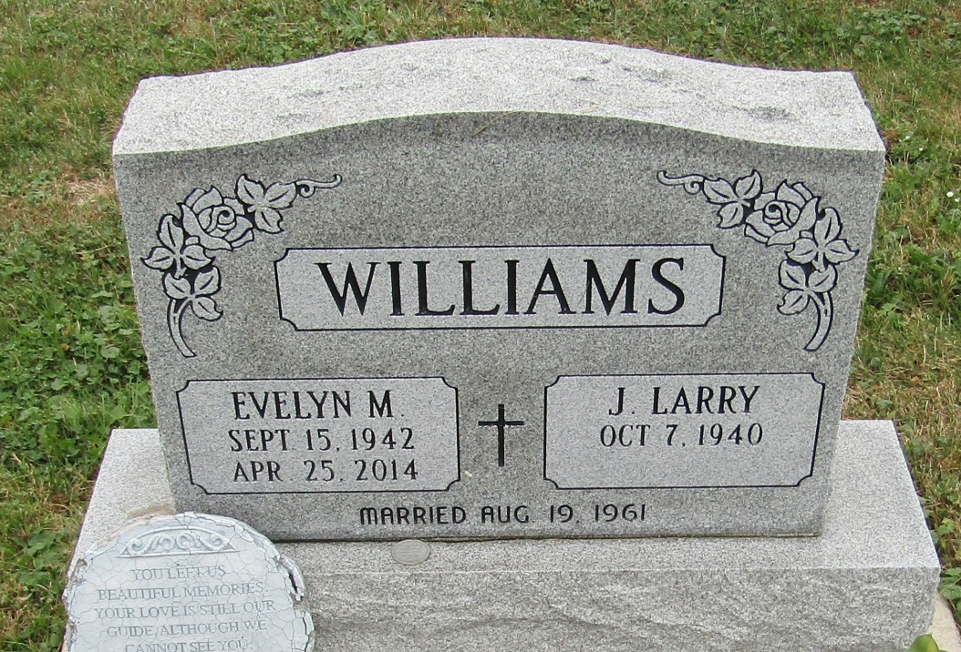

EVELYN M. WILLIAMS, 71, of Fort Wayne, went to be with her Lord on Friday, April 25, 2014 at Hospice Home. She was born in Union County, Ind. on Sept. 15, 1942. She graduated from Short High School. She retired from East Allen County Schools. She was a member of Ossian 1st Presbyterian Church and the Tiger Lilies Garden Club. She is survived by her husband of 52 years, Larry Williams of Fort Wayne; mother, Irene Hartman of Union County, Ind.; four brothers; four sisters; son, Todd (Tamera) Williams of Markle; daughter, Susan (Fiancé, Greg Lawrence) Kostoff of Fort Wayne; and five grandchildren. She was preceded in death by her father, Howard Hartman. Memorial service is 4 p.m. Saturday, May 10, 2014 at Ossian 1st Presbyterian Church, 123 South Jefferson, Ossian, (IN 46777) with visitation from 1 p.m. until the service. Preferred memorials may be made to Ossian 1st Presbyterian Church. Please visit www.elzey-patterson-rodak.com to leave condolences.

Published in Fort Wayne Newspapers on Apr. 27, 2014

