Ralph Martin Walbert
December 6, 1911 – February 15, 1912

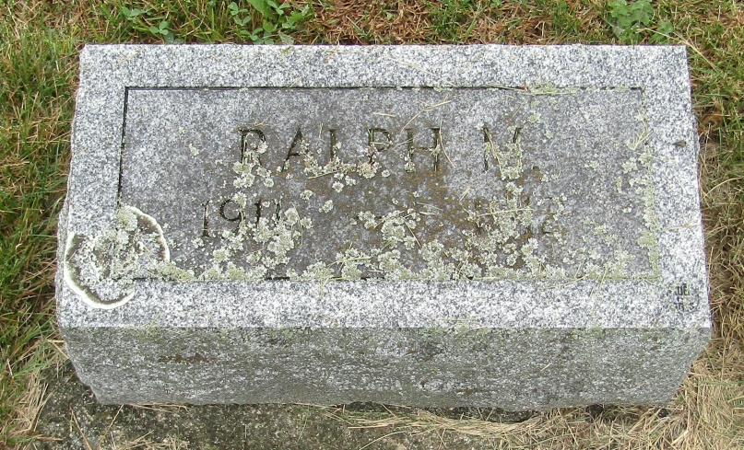

Indiana, Birth Certificates, 1907-1940
Name: Ralph Martin Walbert
Gender: Male
Birth Date: 6 Dec 1911
Birth Place: Rock Creek, Huntington, Indiana, USA
Registration Year: 1911
Father: Martin Watzel Walbert
Mother: Josie Elvie Sheets
Certificate Number: 20571
Roll Number: 006
Agency: Indiana State Dept. of Health
Volume Range: 398 - 404
*****
Indiana, Death Certificates, 1899-2011
Name: Ralf Martin Walburn
Gender: Male
Race: White
Age: 2/12
Birth Date: 6 Dec 1911
Birth Place: Rockcreek Tp
Death Date: 15 Feb 1912
Death Place: Rockcreek, Huntington, Indiana , USA
Father: Martin Walburt
Mother: Josie Sheets
Burial: February 17, 1912; Emanuel Church

