Odessa Dessie “Mina” Smeltzer
June 5, 1891 – January 15, 1903

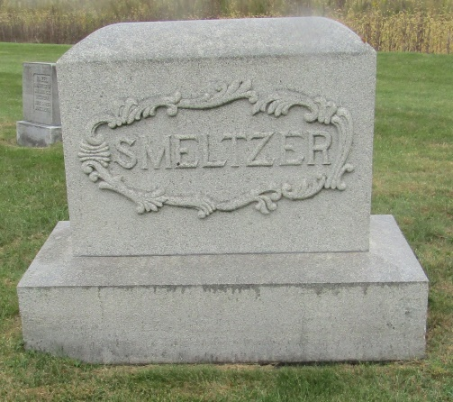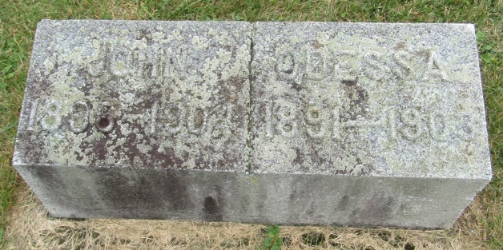

Mina Dessie Smeltzer, daughter of Calvin and Ella Smeltzer, was born in Rock Creek Township, June 5, 1891. She was taken sick a week ago last Friday. She suffered severe pain from an abscess in her head. It then turned into pneumonia which resulted in her death last Thursday evening at about six p.m., aged eleven years, eight months and ten days.
She was a faithful Sunday School member and leaves a blessed memory. (Prayer)

Bluffton Banner, Wells County, Indiana
A weekly newspaper
January 21, 1903

*****
Indiana, Death Certificates, 1899-2011
Name: Dessa Smeltzer
Gender: Female
Race: White
Age: 11 years, 7 months, 10 days
Marital status: Single
Birth Date: 5 Jun 1891
Birth Place: Wells Co
Death Date: 15 Jan 1903
Death Place: Roch Creek, Wells, Indiana, USA
Father: Calvin Smeltzer
Mother: Ella Edris
Burial: January 18; Reform Church

