Ella (Edris) Smeltzer
January 12, 1864 – October 3, 1941

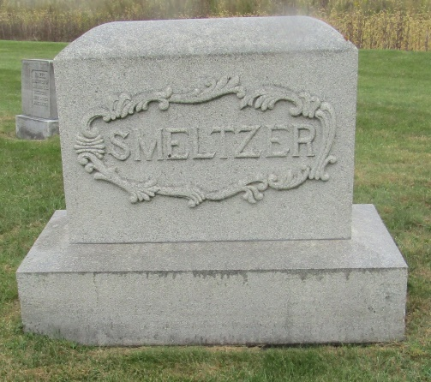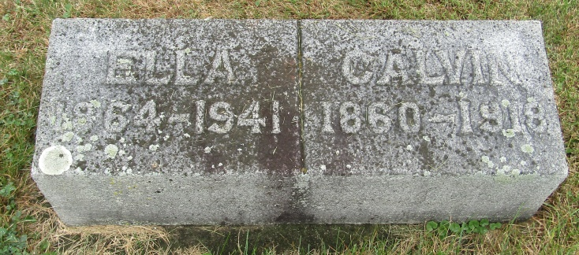

Ella Edris Smeltzer
in the Indiana, Death Certificates, 1899-2011
Name: Ella Edris Smeltzer
[Ella Edris Edris]
Gender: Female
Race: White
Age: 77
Marital status: Widowed
Birth Date: 12 Jan 1864
Birth Place: Pennsylvania
Death Date: 3 Oct 1941
Death Place: Bluffton, Wells, Indiana, USA
Father: Henry Edris
Mother: Emeline ?eber
Spouse: Calvin Smeltzer
Informant: (can't read)
Burial: Oct. 5, 1941; Emanuel Cemetery, Rockford, Indiana

