Thomas B. Skurner
March 9, 1929 – February 18, 2015

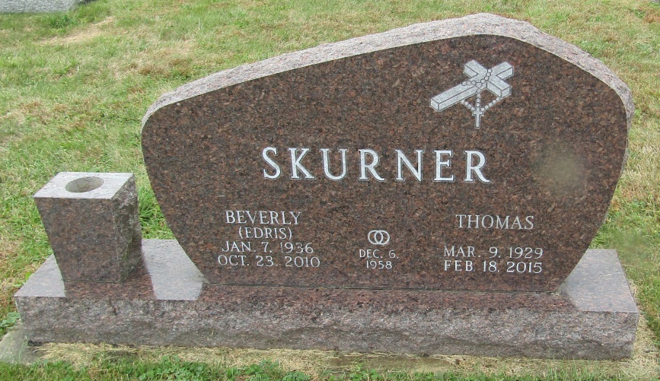

Thomas “Tom” B. Skurner, 85 of Bluffton, passed away at River Terrace Estates at 3:25 PM on Wednesday, February 18, 2015.
Tom was born on March 9, 1929 in Johnstown, PA. to John & Katherine (Lison) Skurner. On December 6, 1958 in Bluffton, Tom and Beverly J. (Edris) Skurner were married. She precedes him in death in 2010.
He served in the United States Army during the Korean Conflict as a First Lieutenant. He worked at Navistar as a metallurgist in Fort Wayne for 30 years and retired in 1994. He was a member of St. Joseph Catholic Church in Bluffton and the American Legion Post #111.
Survivors include his children: Cindy (husband Darrell) Shepherd of Huntertown, IN, Jack (wife Becky) Skurner of LaOtto, IN, Karen (husband Robert) Lesko of Kokomo, IN, James A. (wife Shannon) Skurner of Houston, TX along with nine grandchildren: Michael Shepherd, Janelle Shepherd, Rachel Skurner, Benjamin Skurner, Lauren Lesko, Andrew Lesko, Adam Lesko, Vaughn Skurner and Grant Skurner.
Tom is preceded in death by two brothers, John & Frank Skurner and three sisters, Veronica Slezak, Mary Mizak and Kay Kohler.
A Mass of Christian Burial will be celebrated at 10 a.m. Friday (February 27, 2015) at St. Joseph Catholic Church in Bluffton. Rev. Father Pius N. Ilechukwu will officiate. Burial will follow at Emmanuel Cemetery in Rockford, Indiana. Calling hours will be held from 3 to 8 on Thursday at the Thoma/Rich, Lemler Funeral Home in Bluffton, and for one hour prior to mass at the church. Memorials may be made in Tom’s memory to St. Joseph Catholic Church or Wells County Alzheimer’s Support Group. Funeral arrangements have been entrusted to the care of the Thoma/Rich, Lemler Funeral Home in Bluffton.
Thoma/Rich, Lemler Funeral Home, Wells County, Indiana

