Verna Pauline (Bradburn) Ruble
March 22, 1931 – December 4, 1951

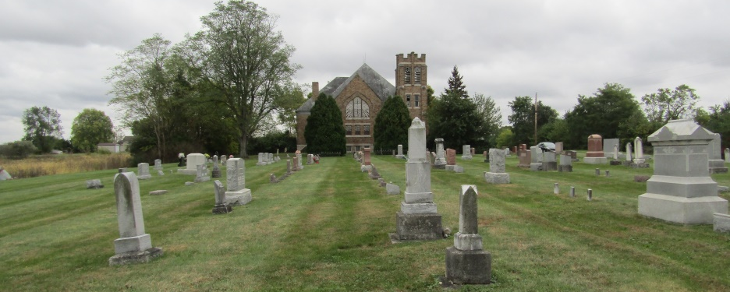

Verna Pauline Ruble
in the Indiana, Death Certificates, 1899-2011
Name: Verna Pauline Ruble
[Verna Pauline Bradburn]
Gender: Female
Race: White
Age: 20
Marital status: Married
Birth Date: 22 Mar 1931
Birth Place: Rock Creek Twp, Wells Co
Death Date: 4 Dec 1951; Embolism following delivery
Death Place: Bluffton, Wells, Indiana, USA
Father: Cecil Bradburn
Mother: Evelyn Schuller
Informant: Mr. Roger Ruble; Bluffton, Indiana
Burial: December 7, 1951; Spider Hill Cemetery, Rockford, Indiana

