Marion Caleb Raber
April 17, 1881 – March 13, 1958

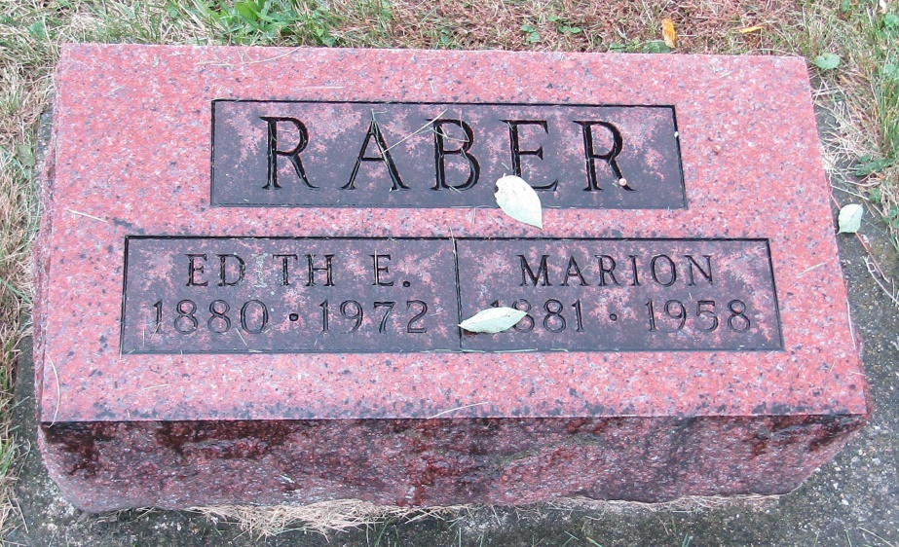

Raber, Marion, 76, of Bluffton died March 13 at Wells County Hospital. Member of the Emmanuel Methodist Church.
Survived by widow, the former Edith Johnson; 4 sons; 3 daughters; 11 grandchildren and 8 great-grandchildren.
Jahn, Goodwin and Reed Funeral Home, Bluffton. Emmanuel Church Cemetery

Montpelier Herald, Blackford County, Indiana
Thursday, March 20, 1958

*****
Indiana, Death Certificates, 1899-2011
Name: Marion Raber
Gender: Male
Race: White
Age: 76
Marital status: Married
Birth Date: 17 Apr 1882
Birth Place: Huntington Co. Ind.
Death Date: 13 Mar 1958
Death Place: Bluffton, Wells, Indiana, USA
Father: Frank Raber
Mother: Catharine Marquart
Informant: Mrs. Marion Raber; wife; Bluffton, Indiana
Burial: March 15, 1958; Emmanuel Cemetery, Wells Co., Indiana

