Lester James Raber
October 15, 1922 – December 23, 1923

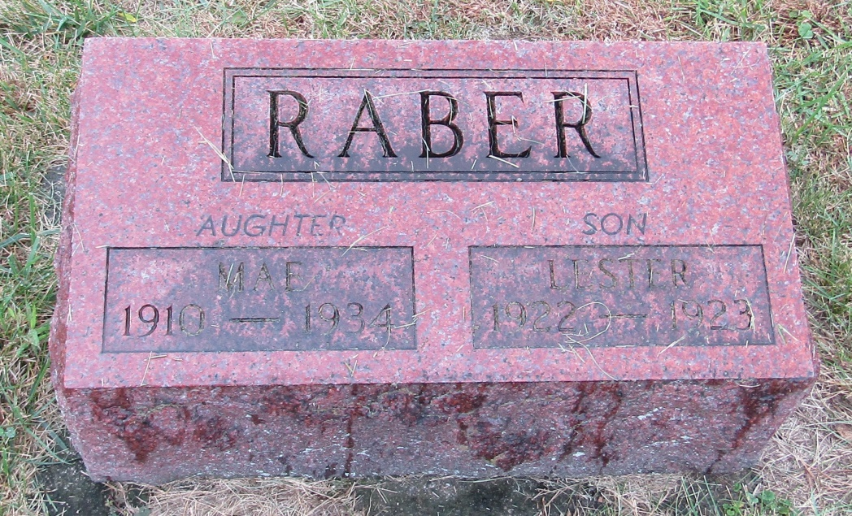

Lester James Raber
in the Indiana, Death Certificates, 1899-2011
Name: Lester James Raber
Gender: Male
Race: White
Age: 1
Marital status: Single
Birth Date: 15 Oct 1922
Birth Place: Wells Co.
Death Date: 23 Dec 1923; bronchio-pneumonia
Death Place: Rockcreek, Wells, Indiana, USA
Father: Marion Raber
Mother: Edith Johnson
Burial: Dec. 25, 1923; Emmanuel Cem., Rockcreek

