Clyde S. “Barney” Miller
February 28, 1920 – February 26, 2006

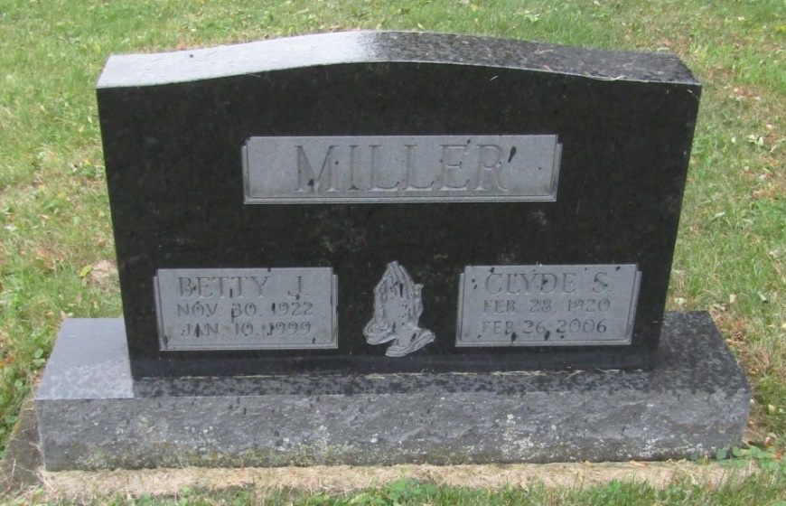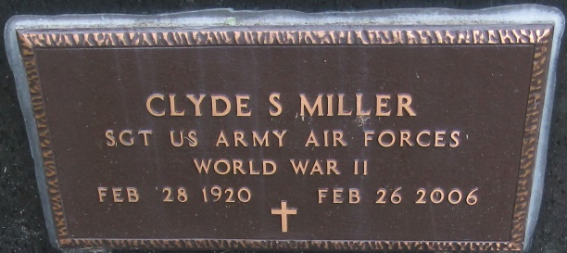

Clyde S. "Barney" Miller, 85, died Sunday morning, Feb. 26, 2006, at his home in Markle. Mr. Miller had been a lifelong self-employed farmer. He was a sergeant in the Army with service during World War II. His unit was attached to the 8th Air Force handling reclamation and repair of aircraft. He was a member of Liberty Center Methodist Church.
Born Feb. 28, 1920, in Huntington County, he was a son of Lewis F. and Edith (Shriner) Miller. His first wife, Betty Jean Eby Miller, died Jan. 10, 1999, after 53 years of marriage. His second marriage, on Nov. 25, 2000, in Markle was to Mary Smith Miller, who survives.
Other survivors include a daughter, Mrs. John (Penny) Collins of Marengo, Ill.; a son, Jerry Allen Miller of Bluffton; stepchildren Phillip Smith of Markle, Fred Smith of Ossian, Jeff Smith of Indianapolis and Keith Smith of Bluffton; siblings Charles Miller of Markle and Pearl Miller of Bluffton; four grandchildren; five great-grandchildren; 12 step grandchildren; and 17 step great-grandchildren. He was preceded in death by a sister, Zelma Forrest; and a brother, Kenneth Miller.
Services are at 10:30 a.m. Saturday at Thoma/Rich, Hewitt & Chaney Funeral Home with Pastor Steve Bard officiating. Calling is from 1 to 8 p.m. Friday and one hour prior to services Saturday, all at the funeral home.
Burial will be in Emmanuel Cemetery, Rockford. Military graveside services will be conducted by American Legion Post #111, Bluffton.
Preferred memorials are to the Liberty Center Church Building Fund.

Bluffton News-Banner, Wells County, Indiana
Monday, February 27, 2006

