Levi Lucabaugh
October 5, 1861 – May 29, 1923

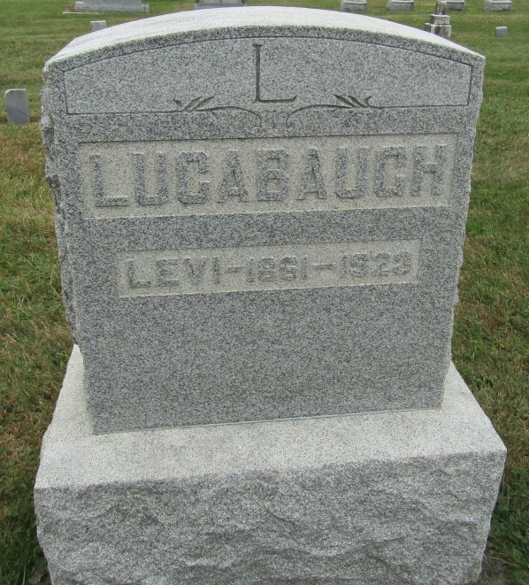

Levi Lucabaugh
in the Indiana, Death Certificates, 1899-2011
Name: Levi Lucabaugh
Gender: Male
Race: White
Age: 61
Marital status: M
Birth Date: 5 Oct 1861
Birth Place: Wayne Co, Ind
Death Date: 29 May 1923
Death Place: Wells, Indiana, USA
Father: Henry Lucabaugh
Mother: Mary Leonard
Spouse: Ida B Galiver
Informant: Mrs. J. Raber; Bluffton, Ind.
Burial: May 31, 1923; Emanuel Cem.

