Opal Marie Lamm
January 17, 1923 – June 6, 2003

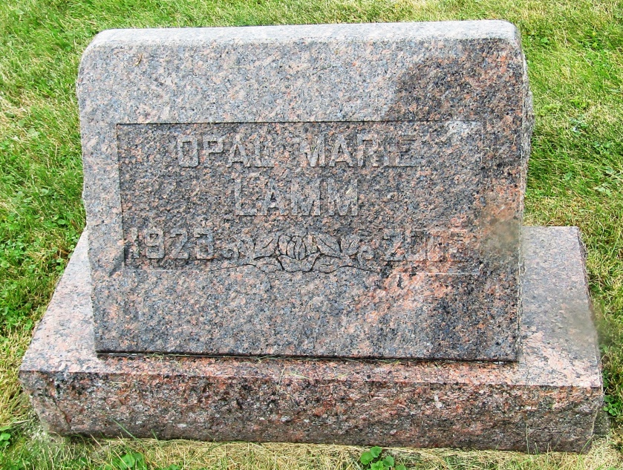

Opal Marie Lamm
in the Indiana, Death Certificates, 1899-2011
Name: Opal Marie Lamm
Gender: Female
Race: White
Age: 80
Marital status: Never Married (Single)
Birth Date: 17 Jan 1923
Birth Place: Bluffton Indiana
Death Date: 6 Jun 2003
Death Place: Fort Wayne, Allen, Indiana, USA
Father: Ora A Lamm
Mother: Ethel I Bayless
Informant: Allison Nommay; niece; Ft. Wayne, Ind.
Burial: June 9, 2003; Emmanuel Cem., Rockford, Ind.

