Ruth Iona King
December 6, 1910 – August 22, 1933

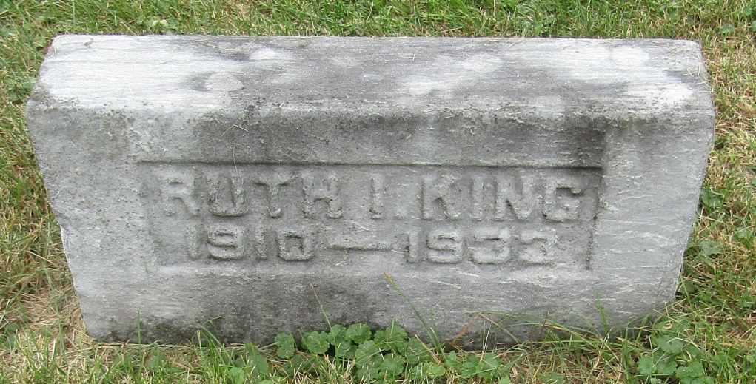

Ruth Jona King
in the Indiana, Death Certificates, 1899-2011
Name: Ruth Iona King
Gender: Female
Race: White
Age: 22
Marital status: Single
Birth Date: 6 Dec 1910
Birth Place: Wells Co Indiana
Death Date: 22 Aug 1933
Death Place: Harrison, Wells, Indiana, USA
Father: Charles King
Mother: Rosa Langel
Informant: Charles King; Bluffton, Ind.
Burial: Aug. 24, 1933; Emmanuel Cem.

