George Elmer Joray
August 5, 1879 – March 9, 1965

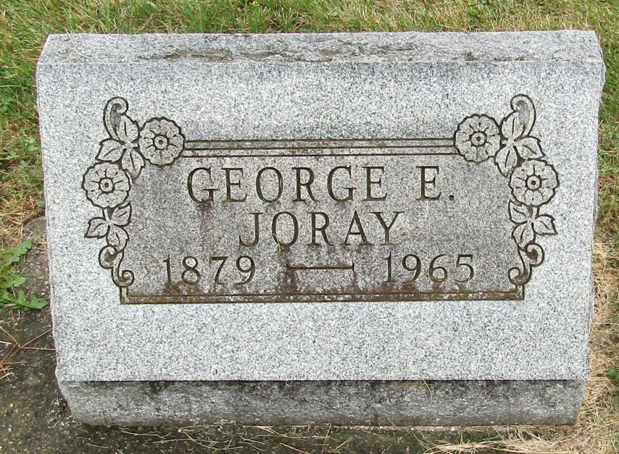

George E Joray
in the Indiana, Death Certificates, 1899-2011
Name: George E Joray
Gender: Male
Race: White
Age: 85
Marital status: Never Married (Single)
Birth Date: 5 Aug 1879
Birth Place: Indiana
Death Date: 9 Mar 1965
Death Place: Bluffton, Wells, Indiana, USA
Father: Samuel Joray
Mother: Esthur Baughman
Informant: Miss Maxine Joray; niece; Bluffton, Ind.
Burial: March 12, 1965; Emanuel Cem., Wells Co., Ind.

