Eva Mae (Buel) Green
October 4, 1926 – February 21, 1946

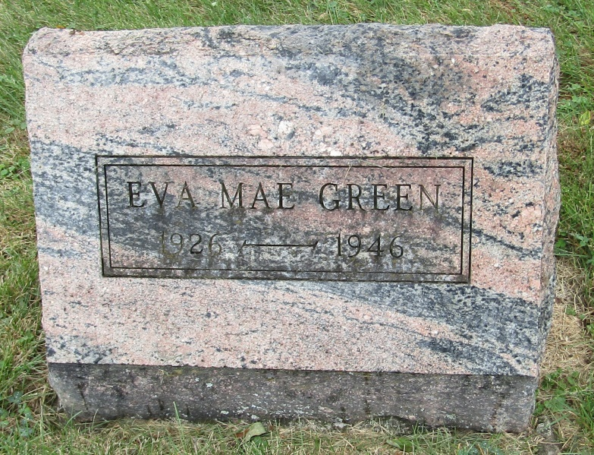

Eva Mae Green
in the Indiana, Death Certificates, 1899-2011
Name: Eva Mae Green
[Eva Mae Buel]
Gender: Female
Race: White
Age: 19
Marital status: Married
Birth Date: 4 Oct 1926
Birth Place: Rock Greek Tp Wells Co
Death Date: 21 Feb 1946
Death Place: Bluffton, Wells, Indiana, USA
Father: Howard Buel
Mother: Della Hime
Spouse: Charles B Green; age 21
Informant: Howard Buel; Bluffton, Ind.
Burial: Feb. 24, 1946; Emanuel Meth. Cem., Wells Co.

