Eugene Elmon Gordon
November 5, 1925 – May 22, 1969

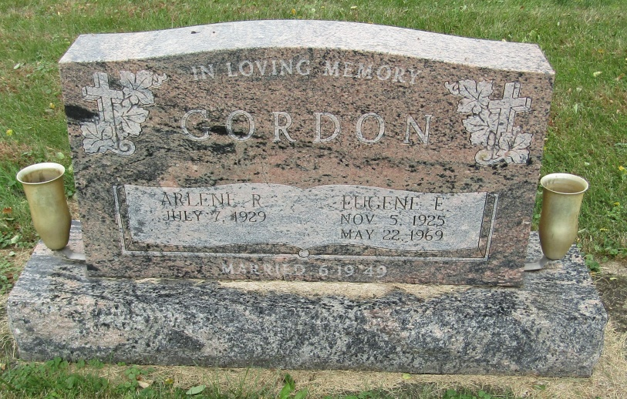

Gene Gorden
in the Indiana, Death Certificates, 1899-2011
Name: Gene Gordon
Gender: Male
Race: White
Age: 43
Marital status: Married
Birth Date: 5 Nov 1925
Birth Place: Ind
Death Date: 22 May 1969; accidental suffocation
Death Place: Bluffton, Wells, Indiana, USA
Father: Clarence Gordon
Mother: Beth Garrett
Spouse: Arlene Buel
Informant: Arlene Gordon; wife; Bluffton, Ind.
Burial: May 25, 1969; Emmanuel Cem., Rockcreek Twp.

