Eva Inez Gesler
June 29, 1888 – December 16, 1969

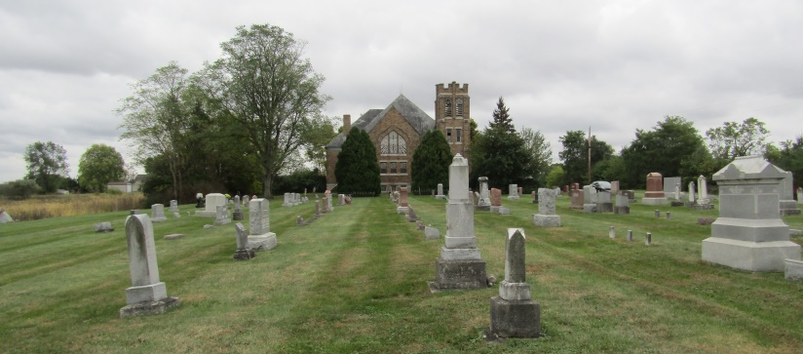

Miss Eva Inez Gesler, 81, of Rockford, died today at Community Hospital. Born in Wells County June 29, 1888, she was a daughter of Lewis and Calista Johnson Gesler.
A lifetime resident of Wells County, she was a member of the Seventh Day Adventist Church of Rockford.
Surviving are two sisters, Mrs. Grace Carter and Mrs. Wilma Koepping, both of Salem, Oregon; and three nieces, including Mrs. Clella Clark of Route 1, Yoder.
Memorial services will be held Saturday at the Rockford Seventh Day Adventist Church. McBride and Son Funeral Home are in charge of arrangements.

Wells County Indiana Obituaries
1969 – 1975

*****
Indiana, Death Certificates, 1899-2011
Name: Eva Inez Gesler
Gender: Female
Race: White
Age: 81
Marital status: Never Married (Single)
Birth Date: 29 Jun 1888
Birth Place: Ind
Death Date: 16 Dec 1969
Death Place: Bluffton, Wells, Indiana, USA
Father: Lewis Gesler
Mother: Calista Johnson
Informant: Mrs. Clella Clark; niece; Yoder, Ind.
Removal: Dec. 17, 1969; Indiana Ma?? Center, Indianapolis, Ind.

