Syntha Almeda (Sparks) Fishbaugh
November 21, 1872 – May 16, 1901

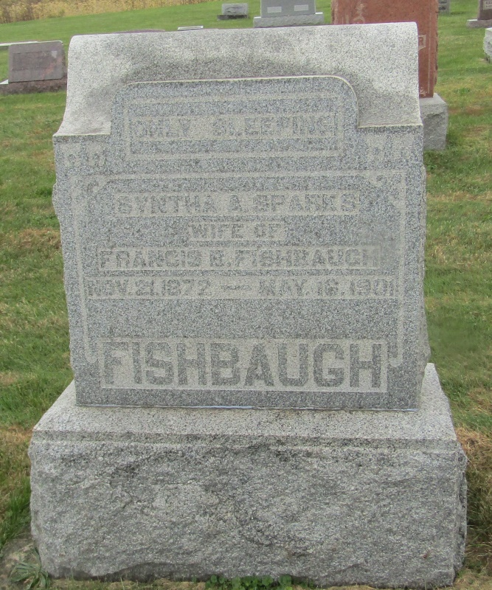

Almeda Fishbaugh
in the Indiana, Death Certificates, 1899-2011
Name: Almeda Fishbaugh
Gender: Female
Race: White
Age: 29
Marital status: Married
Birth Date: abt 1872
Birth Place: Huntington Co
Death Date: May 16, 1901
Death Place: Wells, Indiana, USA
Mother: Martha Robarts
Informant: Chas Fishbaugh; Markle, Ind.
Burial: May 18, 1901; Emanuel's Church

