Laurence Arden Fishbaugh
December 24, 1888 – January 28, 1963

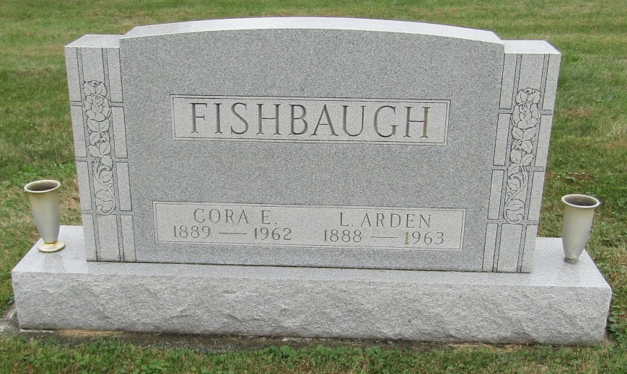
Lorence Arden Fishbaugh
in the Indiana, Death Certificates, 1899-2011
Name: Laurence Arden Fishbaugh
Gender: Male
Race: White
Age: 74
Marital status: Widowed
Birth Date: 24 Dec 1888
Birth Place: Ind
Death Date: 28 Jan 1963
Death Place: Bluffton, Wells, Indiana, USA
Father: Charles Fishbaugh
Mother: Mary King
Informant: Leslie Fishbaugh; son; Uniondale, Ind.
Burial: Jan. 30, 1963; Emmanuel Cem., Rockford, Ind.

