Edna (Wohlfarth) Fishbaugh
November 11, 1911 – February 7, 2011

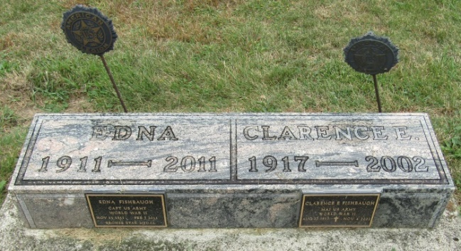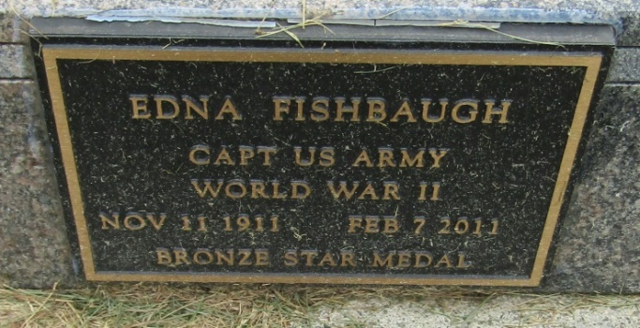

Edna Fishbaugh, 99, of Bluffton, died at 2:30 p.m. Monday, Feb. 7, 2011, at Christian Care Retirement Community. Mrs. Fishbaugh was born in Carlstadt, N.J. on Nov. 11, 1911, to John G. and Bertha (Schumacher) Wohlfarth. She married Clarence E. Fishbaugh in Carlstadt, N.J. on Feb. 20, 1947; he preceded her in death on Nov. 4, 2002.
A 1933 graduate of Columbia University Presbyterian Hospital School of Nursing, Mrs. Fishbaugh served in in England and France with the U.S. Army Nurse Corps from February 1942 to March 1947. She held the rank of Captain and earned three battle stars. She later worked as a surgical nurse. She was a member of the First Reformed Church of Bluffton, Tri Kappa Sorority, the American Legion, The Order of the Eastern Star, and the Columbia University - Presbyterian Hospital School of Nursing Alumni Association.
Surviving relatives include one daughter, Melinda (Dr. Richard) Hamm of Indianapolis; two grandchildren, David (Amanda) Hamm and Laura Hamm (Mark) Peterson, and four great-grandchildren.
Mrs. Fishbaugh was the last of her family of 11 children.
Calling hours will be from 3:30 to 7:30 p.m. Wednesday at the Goodwin Memorial Chapel in Bluffton. A Tri Kappa Memorial Service will be at 7:30 p.m. Wednesday at the funeral home. Funeral services will be at 10:30 a.m. Thursday, at the funeral home with Dr. Bryson E. Bell officiating. Burial is at Emmanuel Cemetery, in Rockford. The American Legion in conjunction with the U.S. Army will hold military rites at the cemetery.
Preferred memorials are to Christian Care Retirement Community's Good Samaritan Fund or the First Reformed Church.

Bluffton News-Banner, Wells County, Indiana
February 8, 2011

