Sarah Emaline (Weber) Edris
September 17, 1843 – January 1, 1922

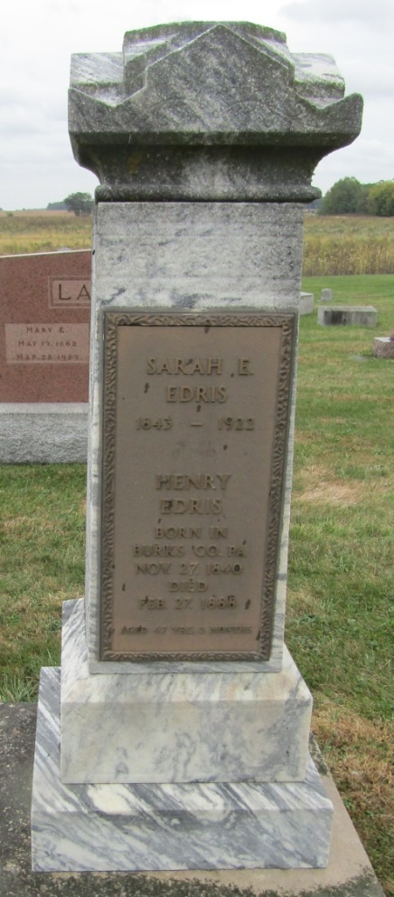

Sarah Emaline Edris
in the Indiana, Death Certificates, 1899-2011
Name: Sarah Emaline Edris
[Sarah Emaline Weber]
Gender: Female
Race: White
Age: 78
Marital status: Widowed
Birth Date: 17 Sep 1843
Birth Place: Berto Co. PA.
Death Date: 1 Jan 1922
Death Place: Bluffton, Wells, Indiana, USA
Father: Lawrence Weber
Mother: Sarah Moyer
Spouse: Henry Edris
Informant: H. W?. Edris; Bluffton, Ind.
Burial: Jan. 3, 1922; Emanuel Cem.

