Louis E. Edris
August 14, 1882 – May 3, 1922

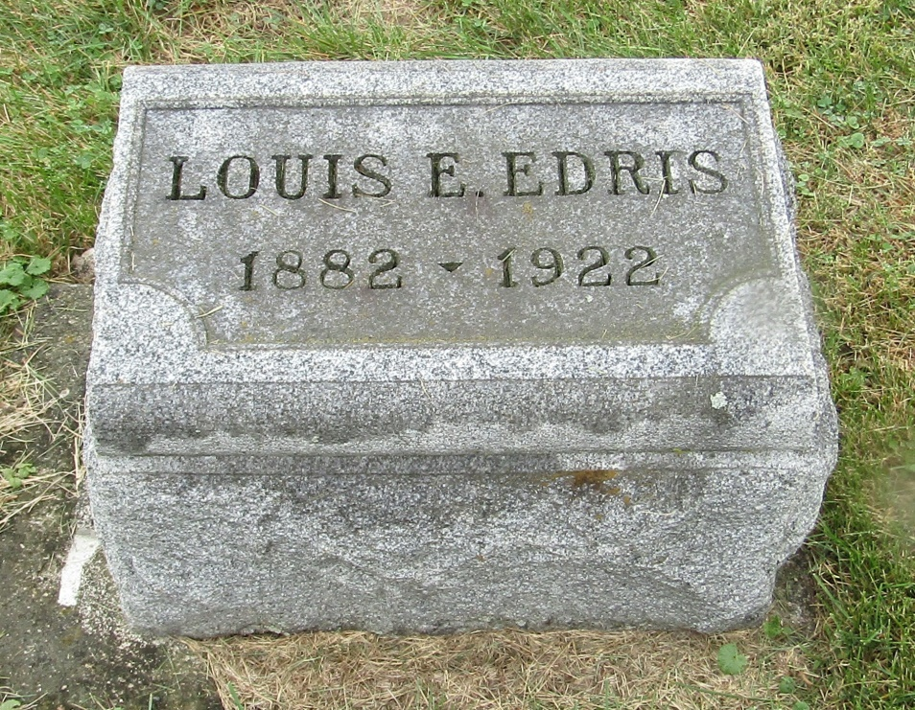

Lowis Edris
in the Indiana, Death Certificates, 1899-2011
Name: Louis Edris
[Louis Edris ]
Gender: Male
Race: White
Age: 39
Marital status: Married
Birth Date: 14 Aug 1882
Birth Place: Indiana
Death Date: 3 May 1922
Death Place: Clinton, Cass, Indiana, USA
Spouse: Golda
Burial or Removal: May 4, 1922; Bluffton, Ind.

