Henry Edris
November 27, 1840 – February 27, 1888

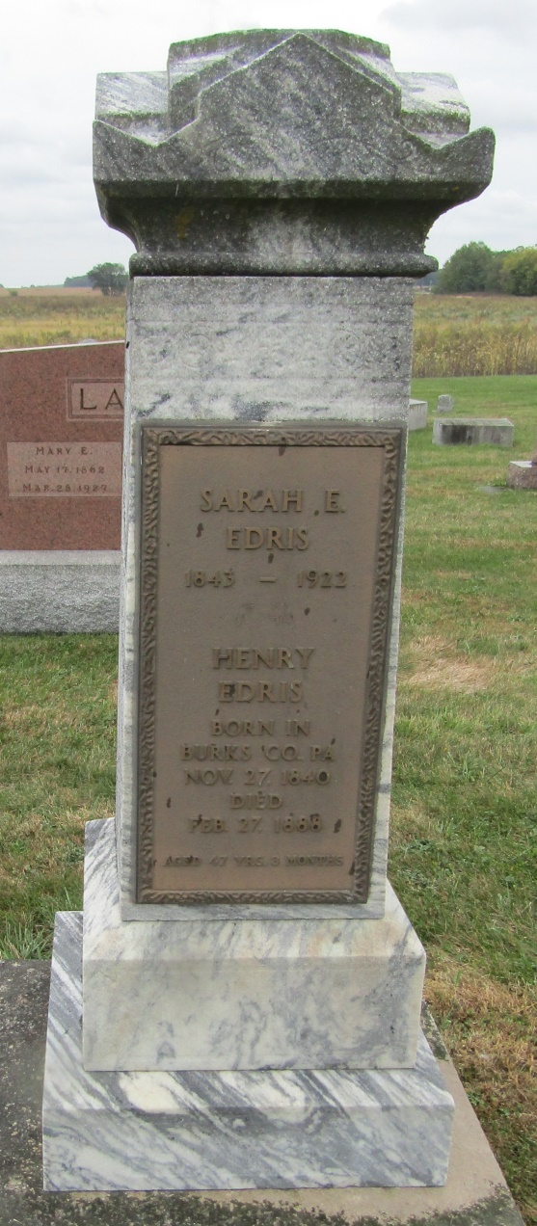

No obit found at this time.

Biography

Henry Edris, engaged in farming and stock-raising on section 30, Rock Creek Township, is a native of Lebanon County, Pennsylvania, the date of his birth being November 26, 1840. He is a son of Leonard and Elizabeth (Spitler) Edris, who were natives of the State of Pennsylvania and of German descent. His father died when he was an infant, and left him with his mother, with whom he remained until he grew to manhood, and was reared to the avocation of a farmer.
He was married January 12, 1863, to Miss Emeline Weber, daughter of Lawrence and Sarah (Moyer) Weber, natives of Berks County, Pennsylvania, of German ancestry. Her father was a son of Peter and Susanna (Raber) Weber, and grandson of Henry Weber, who was a native of Germany, and her mother, was a daughter of Peter and Catherine (Edris) Moyer, and a granddaughter of George
and Susanna (Piffer) Moyer.
Mr. and Mrs. Edris are the parents of eight children - Mary E., wife of John Smeltzer; Edwin L., Henry M., Aaron C.,Milton P., Sarah E., Harry E., and Louis E. In 1864 Mr. Edris came with his father-in-law’s family to Wells County, Indiana, and settled on the farm on Section 30, Rock Creek Township, where he has since followed agricultural pursuits. But little of his land had been cleared when he settled, but by persevering industry and good management he has cleared and improved his farm, which now consists of 159 acres of well cultivated land. He and his wife are members of the Reformed church. In his political views he us a Democrat.

Biographical and Historical Record of Adams and Wells Counties, Chicago: The Lewis Publishing Company, 1887, p. 903.

