David Laree Edris
August 22, 1939 – September 10, 1949

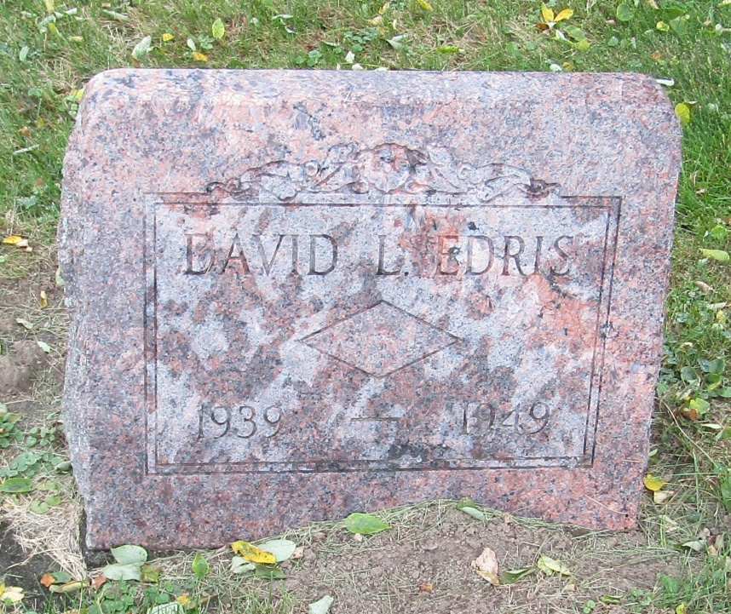

David Edris
in the Indiana, Death Certificates, 1899-2011
Name: David Edris
Gender: Male
Race: White
Age: 10
Birth Date: 22 Aug 1939
Birth Place: Wells Co Ind
Death Date: 10 Sep 1949
Death Place: Rural, Wells, Indiana, USA
Father: Lester Edris
Mother: Lucile McLaughen
Informant: Mr. Lewis Edris; Liberty Center
Burial: Sept. 12, 1949; Emanuel Cem., Wells Co.

