John Daniel Eby
October 17, 1883 – July 18, 1944

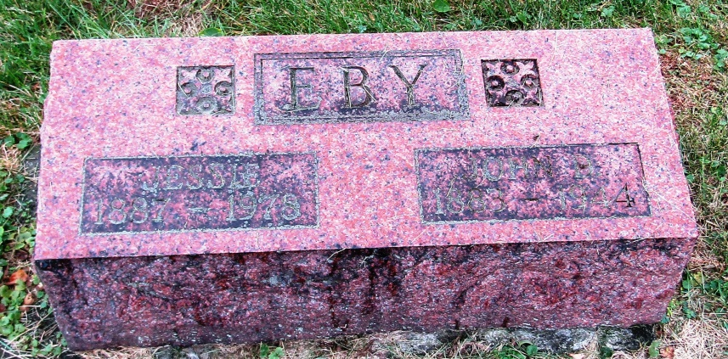

John Daniel Eby
in the Indiana, Death Certificates, 1899-2011
Name: John Daniel Eby
Gender: Male
Race: White
Age: 60
Marital status: Married
Birth Date: 17 Oct 1883
Birth Place: Sbelbyville, Ill
Death Date: 18 Jul 1944
Death Place: Rural, Wells, Indiana, USA
Father: Jacob Edwin Eby
Mother: Katharine Seltzer
Spouse: Jessie Allen; age 56 years
Informant: Mrs. John Eby; Bluffton, Ind.
Burial: July 19, 1944; Emanuel Cem., Rockcreek Twp.

