Jacob Edwin Eby
March 10, 1852 – January 9, 1934

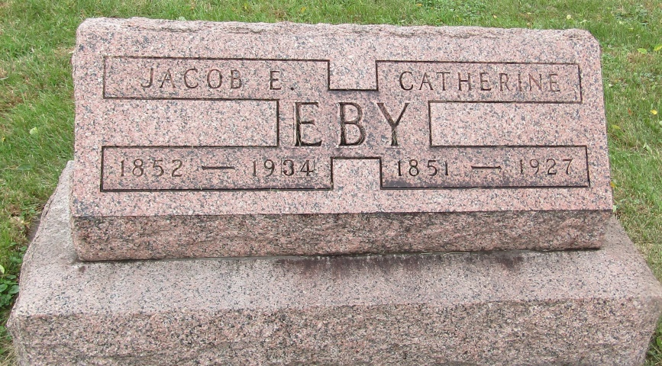

Jacob Eby
in the Indiana, Death Certificates, 1899-2011
Name: Jacob Eby
Gender: Male
Race: White
Age: 81
Marital status: Widowed
Birth Date: 10 Mar 1852
Birth Place: Pennsylvania
Death Date: 9 Jan 1934
Death Place: Bluffton, Wells, Indiana, USA
Father: Jacob Eby
Mother: Eliza Shock
Spouse: Kate Setezer
Informant: John Eby; Bluffton, Ind.
Burial: Jan. 11, 1934; Emanuel Cem., Wells Co.

