Catharine (Lesh) Earhart
September 2, 1821 – January 6, 1905

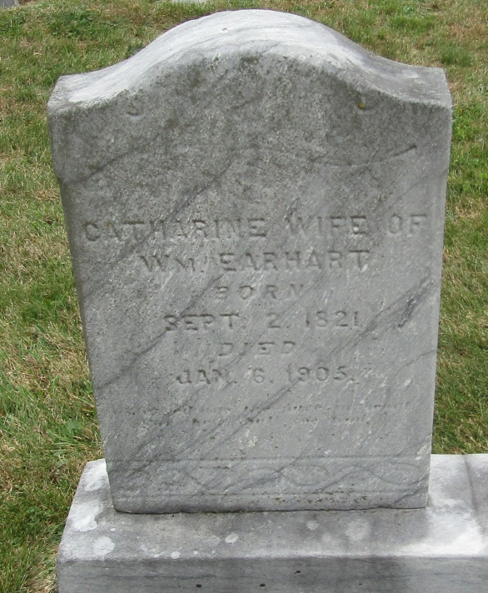

Name: Catherine Earhart
[Catharine Earhart ]
[Catherine Lesh]
Gender: Female
Race: White
Age: 83
Marital status: Widowed
Birth Date: 2 Sep 1821
Birth Place: PA
Death Date: 6 Jan 1905
Death Place: Markle, Huntington, Indiana, USA
Father: John Lesh
Mother: Elizabeth Ulrich
Spouse: Wm Earhart
Informant: John Beaty; Ossian, Ind.
Burial: Jan. 8, 1905; Reform Church

