Theodore Tilton Dill
January 20, 1867 – April 1, 1927

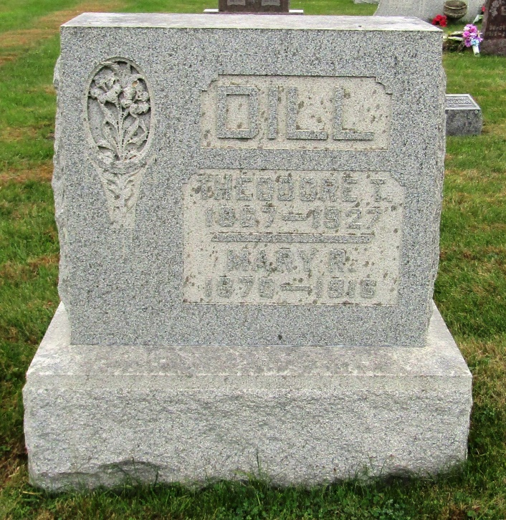

Theodore T. Dill
in the Indiana, Death Certificates, 1899-2011
Name: Theodore T. Dill
Gender: Male
Race: White
Age: 60
Marital status: Married
Birth Date: 20 Jan 1867
Birth Place: Ind
Death Date: 1 Apr 1927
Death Place: Markle, Huntington, Indiana, USA
Father: John Dill
Mother: May Lawson
Spouse: A.
Informant: Mrs. T. Dill; Markle, Ind.
Burial: April 3, 1927; German Reform Cem.

