Anna May (Lawson) Dill
March 13, 1831 – August 28, 1904

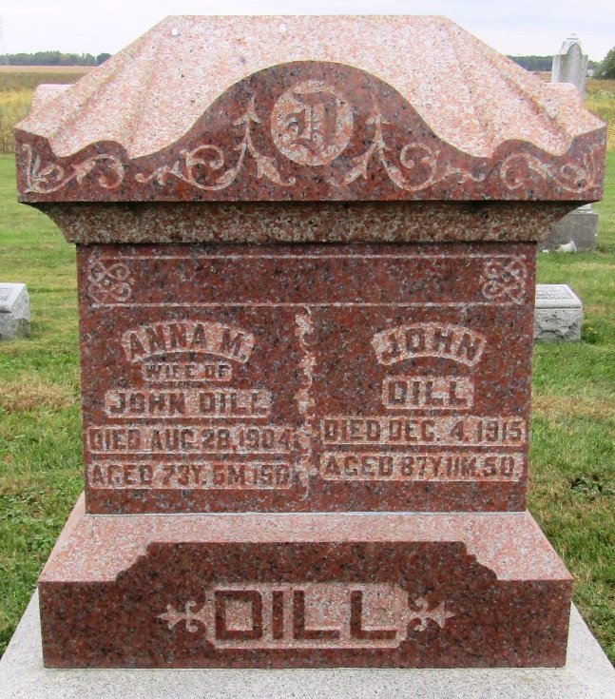

Anna Mary Lawson, a daughter of Mr. and Mrs. John M. Lawson, was born March 13, 1831, in Wayne County, near Cambridge City. She was married to John Dill May 10, 1849. They came to Rockcreek Township, Huntington County, in the fifties where they lived ever since.
Their union was blessed with two sons and two daughters, Isaiah Dill of Michigan, Theodore Tilton died [sic]on the old home place, Mrs. John Brown and Mrs. Daniel Miller who live in the community.
After a prolonged illness of about five months, she was called home Sunday evening, August 28, 1904, aged seventy-three years, five months and fifteen days. Her father had been an active worker all his life in the United Brethren Church. She became a member of the same church in her early life.
The funeral services were held Tuesday afternoon at the Emmanuel's Reformed Church in Rockcreek Township. Rev. H. A. Welker preached the sermon on the text St. John 14:2, 3. Interment was made in the cemetery adjoining the church.
She leaves to mourn their loss her husband and four children.

Huntington Weekly News, Huntington County, Indiana
Friday, September 2, 1904
*****

Indiana, Death Certificates, 1899-2011
Name: Anna May Dill
[Anna May Lawson]
Gender: Female
Race: White
Age: 73
Marital status: Married
Birth Date: 13 Mar 1831
Birth Place: Wayne Co Ind
Death Date: 28 Aug 1904
Death Place: Rock Creek, Huntington, Indiana, USA
Father: Jno Lawson
Mother: Cathrine Harb
Spouse: Jno Dill
Informant: Lilley Dill; Ind.
Burial: Aug. 30, 1904; Reform Church

