Edward Decker
July 19, 1846 – December 7, 1916

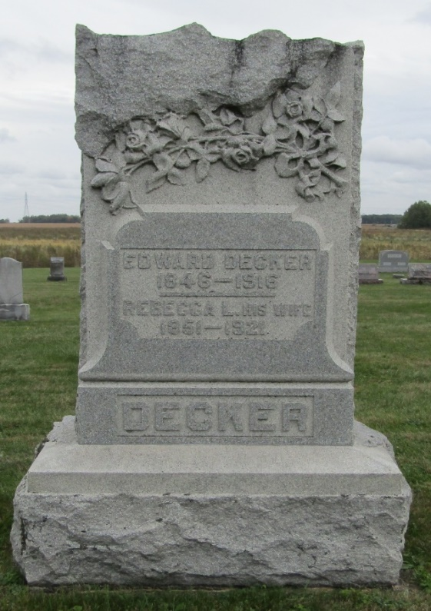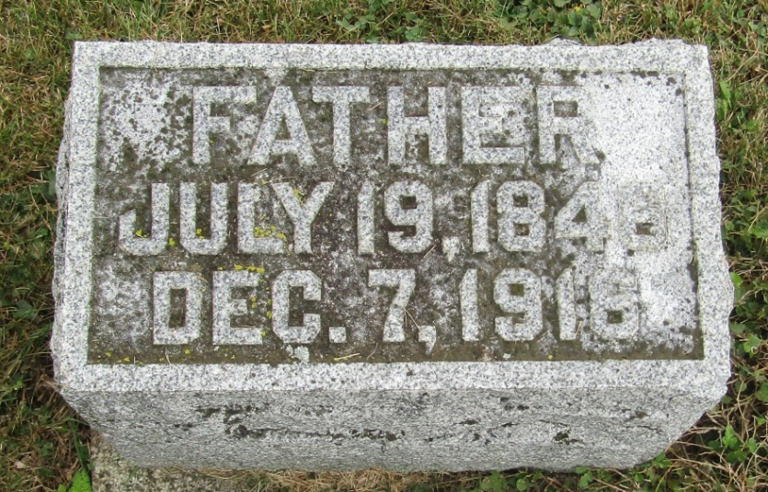

Edward Deeker
in the Indiana, Death Certificates, 1899-2011
Name: Edward Decker
Gender: Male
Race: White
Age: 70
Marital status: Married
Birth Date: 19 Jul 1846
Birth Place: Ohio
Death Date: 7 Dec 1916
Death Place: Rose Creek, Wells, Indiana , USA
Father: Isaac Decker
Mother: Elizabeth Houser
Spouse: Rebecca
Informant: C. W. Decker; Bluffton, Ind.
Burial: Dec. 9, 1916; Reform Church

